Contents
What are Work Patterns 2
Accessing the Work Patterns screen 2
How to Add a new Work Pattern 3
How to Copy a Work Pattern 4
Configuration of a Work Pattern 4
General Parameters 4
Additional Configuration not currently utilised 6
Standard Hours 6
Breaks 6
Absence 6
Overtime 6
Flexitime Settings 6
Alternate Patterns 6
Premiums 6
Rostering 6
Roster Allowances 6
Alternate Premium Patterns 6
Bonus Payments 7
Time Based Bonus 7
Work Pattern Mapping 7
Miscellaneous Settings 7
NCHD Settings 7
Security - Menu Profiles and Menu Options 7

Document Version Control
Change History/Review Details
Date | Version | Review by | Summary of Change
02-FEB-2024 | 1.0 | MJOS | Initial draft following migration of Work Patterns from back office into the Portal

What are Work Patterns
Work Patterns define a daily work schedule. They identify the different work durations that exist within the organisation and capture the expected working hours for an employee. Selected work patterns are then used to configure an employee’s shift type. Work patterns are an integral part of the system linking to multiple areas.

Accessing the Work Patterns screen
The Work Pattern screen is where administrators can manage work patterns for their organisation. The screen lists all Work Patterns created and shows if they are active or not. This screen can be used to create new work patterns, copy existing work patterns and further configure patterns to organisational requirements.
To access the Work Patterns screen, navigate via
WFM Admin Dashboard > WFM Configuration > select Work Patterns.
The following Work Patterns screen displays.
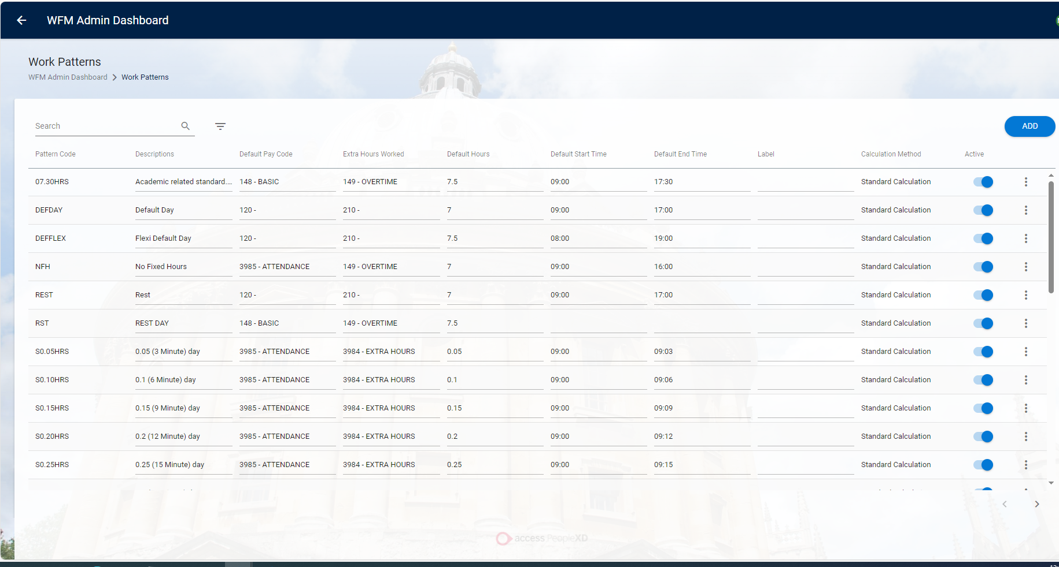
There is a search and filter option available on the Work Patterns screen, allowing you to search for a specific work pattern or filter by Default Pay Code, Extra Hours Worked, Active or Label.
The screen contains the following fields:
Option | Details
Pattern Code | The Code given to the Work Pattern.
Description | The Work Pattern description.
Default Pay Code | The pay code assigned to the work pattern.
Extra Hours Worked | The pay code assigned to extra hours worked on the work pattern.
Default Hours | Number of hours of the work pattern.
Default Start Time | The start time of the work pattern.
Default End Time | The end time of the work pattern.
Label | The label added to the work pattern to make it easily searchable.
Calculation Method | The calculation method of the work pattern. For example, Standard, Roster or Rest Pattern.
Active Indicator | When the active indicator is enabled the work pattern is available to be added to a Shift Type.

How to Add a new Work Pattern
To add a new work pattern, complete the following steps:

1. Click Add at the top of the screen.
2. Fill in the mandatory fields Pattern Code, Description, Default Pay Code, Extra Hours Worked, Default Hours, Default Start Time, Default End Time, Earliest Start Time.
3. Click OK.
4. Your new Work Pattern will open for you to further configure, using the tabs on the left-hand side. For example, add Standard Hours and Breaks.
5. Once your Work Pattern is fully configured, click Save.
6. Your Work Pattern is now ready to be added to a Shift Type.

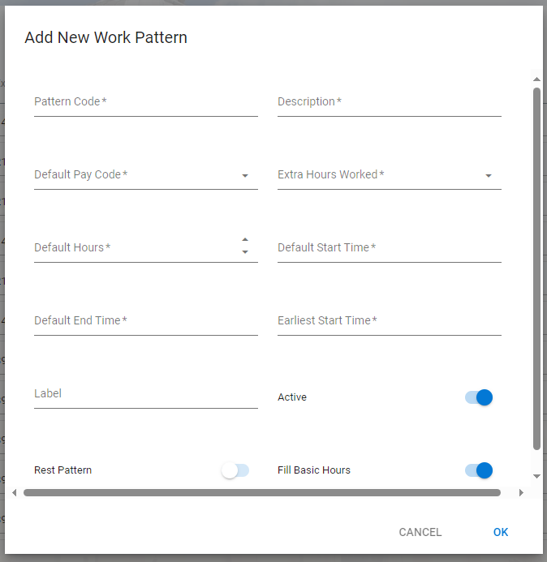

How to Copy a Work Pattern
To copy a work pattern, complete the following steps:

1. Select Copy from the 3-dot menu of the work pattern you wish to copy.
2. Fill in the Pattern Code.
3. Fill in the Description.
4. Click OK.
5. Your copied Work Pattern will open for you to further configure.

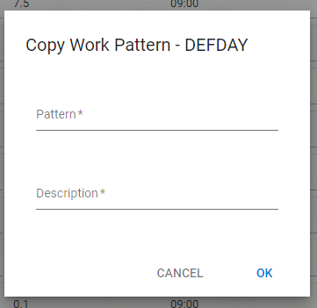

Configuration of a Work Pattern
The configuration screens allow you to customise and configure work patterns and can be accessed through the Work Patterns screen by selecting the 3-dot ellipses and selecting View/Edit Work Pattern.
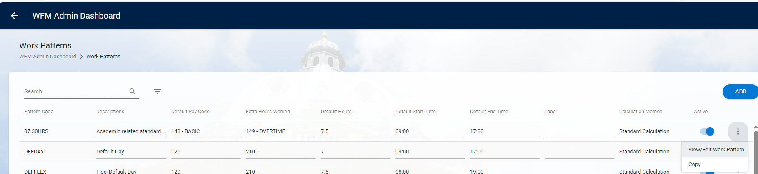

General Parameters
At the current time only the General Parameters screen is utilised, however as further functionality such as Rostering is introduced the other areas are likely to require configuration.
The General Parameters screen contains the main information pertaining to the Work Pattern and allows to configure for example, default hours as well as start and end time. As with all of the other screens, the Start Time, End Time and Default Hours are displayed at the top of the screen.
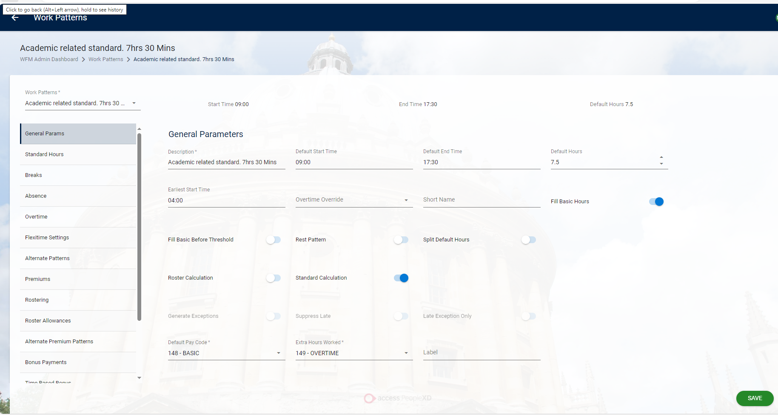
The General Params screen contains the following fields:
Field | Details
Description | This allows you to choose the specific work pattern.
Default Start Time | This is the start time which the system defaults to.
Default End Time | This is the end time which the system defaults to.
Default Hours | These are the hours which will be filled in automatically.
Earliest Start Time | You can choose the earliest time that the work pattern can start.
Overtime Override | If you wish to override the default hours in the case of over time you can do so here.
Short Name | You can give the pattern a short two letter abbreviation.
Fill Basic Hours | When this toggle is enabled, basic hours can be filled.
Fill Basic Before Threshold | When the toggle is enabled, basic hours can be filled up to the specific threshold.
Rest Pattern | When the toggle is enabled, the hours are put on a rest pattern.
Split Default Hours | When enabled this will split the default hours.
Roster Calculation | When the toggle is enabled the menu and options are only the ones for a roster (previously known as retail) calculation.
Standard Calculation | When enabled the hours are calculated as standard hours.
Default Pay Code | You can set a pay code for the system to default to. This is a mandatory field.
Extra Hours Worked | You can choose the pay code for any extra hours worked.
Label | It is advisable to label the pattern with a short name to increase searchability.

Additional Configuration not currently utilised
The following screens have been enabled when migrating Work Patterns from the Back Office into the Portal, but are not currently utilised.

Standard Hours
The Standard Hours screen shows you the standard hours in a work pattern and allows you to add and sequence the hours as well as adding extra information using the 3-dot menu.

Breaks
The Breaks Screen lets you view and add break patterns in a sequence. You can also configure clockings or penalties for employees and teams.

Absence
The Absence Screen is a new screen which amalgamates all the previous absence screens and bringing them all together in one place. It allows you to configure full and part day values as well as configure manager approval.

Overtime
The Overtime screen centralises all of the previous overtime options from the Back Office together on one screen.

Flexitime Settings
The Flexitime screen amalgamates all the previous flexitime settings from the Back Office on to one screen and includes adding new sequence items.

Alternate Patterns
The Alternate Patterns screen has amalgamated Alternate pattern information and creation in to one screen

Premiums
The Premiums Screen is in two parts. The main information displayed on the fixed left-hand side of the screen such as the Worked Pay code and Thresholds. Additional settings are shown on the scrolling right-hand side of the screen allow you to view more detailed information.

Rostering
All rostering configuration is now amalgamated on the Rostering Screen, having been migrated from the Back Office.

Roster Allowances
On this screen, you can create and configure a roster allowance all on the one screen, since the previous screens have now been amalgamated on Portal.

Alternate Premium Patterns

Bonus Payments
The Bonus Payments Screen allows you to configure payments for bonus hours which have been worked by your team.

Time Based Bonus

Work Pattern Mapping

Miscellaneous Settings

NCHD Settings

Security - Menu Profiles and Menu Options
All menu options from the Access Group standard menu profile WFM_WORK_PATTERNS have been imported into the menu profile COREPORTAL_SUPPORT, which is shared with the central HR Systems team members.
The following menu options can be used to customise access to the Work Patterns screens as required. These have been added to the COREPORTAL_SUPPORT menu profile matrix.
Menu Option | Menu ID | System
Pattern Codes | CONFIG_SET_MENU.PATTERN_CODES | CorePortal
Work Patterns | CONFIG_SET_MENU.WORK_PATTERNS | CorePortal
Get patterntypes | WS_ROSTER_MENU.GET_PATTERNTYPES | Web Services
Update patterntypes | WS_ROSTER_MENU.PATCH_PATTERNTYPES_ID | Web Services
Delete patterntypes | WS_ROSTER_MENU.DELETE_PATTERNTYPES | Web Services
Get patterntypes label | WS_ROSTER_MENU.GET_PATTERNTYPES_LABEL | Web Services
Get workpattern | WS_ROSTER_MENU.GET_WORKPATTERN | Web Services
Update workpattern | WS_ROSTER_MENU.PATCH_WORKPATTERN_ID | Web Services
Delete workpattern | WS_ROSTER_MENU.DELETE_WORKPATTERN_ID | Web Services
Create workpattern | WS_ROSTER_MENU.POST_WORKPATTERN | Web Services
Create workpattern copy | WS_ROSTER_MENU.POSTWORKPATTERN_COPY | Web Services
Get workpattern mapping | WS_ROSTER_MENU.GET_WORKPATTERN_MAPPING | Web Services
Update workpattern mapping | WS_ROSTER_MENU.PATCH_WORKPATTERN_MAPPING_ID | Web Services
Delete workpattern mapping | WS_ROSTER_MENU.DELETE_WORKPATTERN_MAPPING | Web Services
Create workpattern mapping | WS_ROSTER_MENU.POST_WORKPATTERN_MAPPING | Web Services
Get workpattern breaks | WS_ROSTER_MENU.GET_WORKPATTERN_BREAKS | Web Services
Update workpattern breaks | WS_ROSTER_MENU.PATCH_WORKPATTERN_BREAKS_ID | Web Services
Create workpattern breaks | WS_ROSTER_MENU.POST_WORKPATTERN_BREAKS | Web Services
Delete workpattern breaks | WS_ROSTER_MENU.DELETE_WORKPATTERN_BREAKS_ID | Web Services
Create workpattern flexitime | WS_ROSTER_MENU.POST_WORKPATTERN_FLEXITIME | Web Services
Update workpattern flexitime | WS_ROSTER_MENU.PATCH_WORKPATTERN_FLEXITIME_ID | Web Services
Create workpattern flexitime | WS_ROSTER_MENU.POST_WORKPATTERN_FLEXITIME | Web Services
Delete workpattern flexitime | WS_ROSTER_MENU.DELETE_WORKPATTERN_FLEXITIME_ID | Web Services
Get workpattern bonuspayments | WS_ROSTER_MENU.GET_WORKPATTERN_BONUSPAYMENTS | Web Services
Update workpattern bonuspayments | WS_ROSTER_MENU.PATCH_WORKPATTERN_BONUSPAYMENTS_ID | Web Services
Create workpattern bonuspayments | WS_ROSTER_MENU.POST_WORKPATTERN_BONUSPAYMENTS | Web Services
Delete workpattern bonuspayments | WS_ROSTER_MENU.DELETE_WORKPATTERN_BONUSPAYMENTS_ID | Web Services
Create workpattern timebasedbonus | WS_ROSTER_MENU.POST_WORKPATTERN_TIMEBASEDBONUS | Web Services
Delete workpattern timebasedbonus | WS_ROSTER_MENU.DELETE_WORKPATTERN_TIMEBASEDBONUS_ID | Web Services
Get workpattern timebasedbonus | WS_ROSTER_MENU.GET_WORKPATTERN_TIMEBASEDBONUS | Web Services
Update workpattern timebasedbonus | WS_ROSTER_MENU.PATCH_WORKPATTERN_TIMEBASEDBONUS_ID | Web Services
Create workpattern alternatepremiums | WS_ROSTER_MENU.POST_WORKPATTERN_ALTERNATEPREMIUMS | Web Services
Delete workpattern alternatepremiums | WS_ROSTER_MENU.DELETE_WORKPATTERN_ALTERNATEPREMIUMS_ID | Web Services
Get workpattern alternatepremiums | WS_ROSTER_MENU.GET_WORKPATTERN_ALTERNATEPREMIUMS | Web Services
Update workpattern alternatepremiums | WS_ROSTER_MENU.PATCH_WORKPATTERN_ALTERNATEPREMIUMS_ID | Web Services
Create workpattern alternatepatterns | WS_ROSTER_MENU.POST_WORKPATTERN_ALTERNATEPATTERNS | Web Services
Delete workpattern alternatepatterns | WS_ROSTER_MENU.DELETE_WORKPATTERN_ALTERNATEPATTERNS_ID | Web Services
Get workpattern alternatepatterns | WS_ROSTER_MENU.GET_WORKPATTERN_ALTERNATEPATTERNS | Web Services
Update workpattern alternatepatterns | WS_ROSTER_MENU.PATCH_WORKPATTERN_ALTERNATEPATTERNS_ID | Web Services
Create workpattern premiums | WS_ROSTER_MENU.POST_WORKPATTERN_PREMIUMS | Web Services
Delete workpattern premiums | WS_ROSTER_MENU.DELETE_WORKPATTERN_PREMIUMS_ID | Web Services
Get workpattern premiums | WS_ROSTER_MENU.GET_WORKPATTERN_PREMIUMS | Web Services
Update workpattern premiums | WS_ROSTER_MENU.PATCH_WORKPATTERN_PREMIUMS_ID | Web Services
Create workpattern rosterallowances | WS_ROSTER_MENU.POST_WORKPATTERN_ROSTERALLOWANCES | Web Services
Delete workpattern rosterallowances | WS_ROSTER_MENU.DELETE_WORKPATTERN_ROSTERALLOWANCES_ID | Web Services
Get workpattern rosterallowances | WS_ROSTER_MENU.GET_WORKPATTERN_ROSTERALLOWANCES | Web Services
Update workpattern rosterallowances | WS_ROSTER_MENU.PATCH_WORKPATTERN_ROSTERALLOWANCES_ID | Web Services
Create workpattern standardhours | WS_ROSTER_MENU.POST_WORKPATTERN_STANDARDHOURS | Web Services
Delete workpattern standardhours | WS_ROSTER_MENU.DELETE_WORKPATTERN_STANDARDHOURS_ID | Web Services
Get workpattern standardhours | WS_ROSTER_MENU.GET_WORKPATTERN_STANDARDHOURS | Web Services
Update workpattern standardhours | WS_ROSTER_MENU.PATCH_WORKPATTERN_STANDARDHOURS_ID | Web Services

